Iowa Society DAR Scholarship
Amelia Jenks Bloomer Scholarship

Iowa Society Daughters of the American Revolution provides two college scholarships for graduating high school students who plan to attend a U.S. Department of Education accredited school of post-secondary education. Each scholarship is in the amount of $1000.
Criteria:
- Must be an American citizen and an Iowa resident and be of good character
- Plan on attending a U.S. Department of Education accredited school of post-secondary education
- Have a minimum grade point average of 3.0 based on a 4.0 scale
- Show merit and financial need
- Be recommended by the Chapter Regent; each ISDAR chapter is entitled to 1 nomination per scholarship
- Be received by February 1

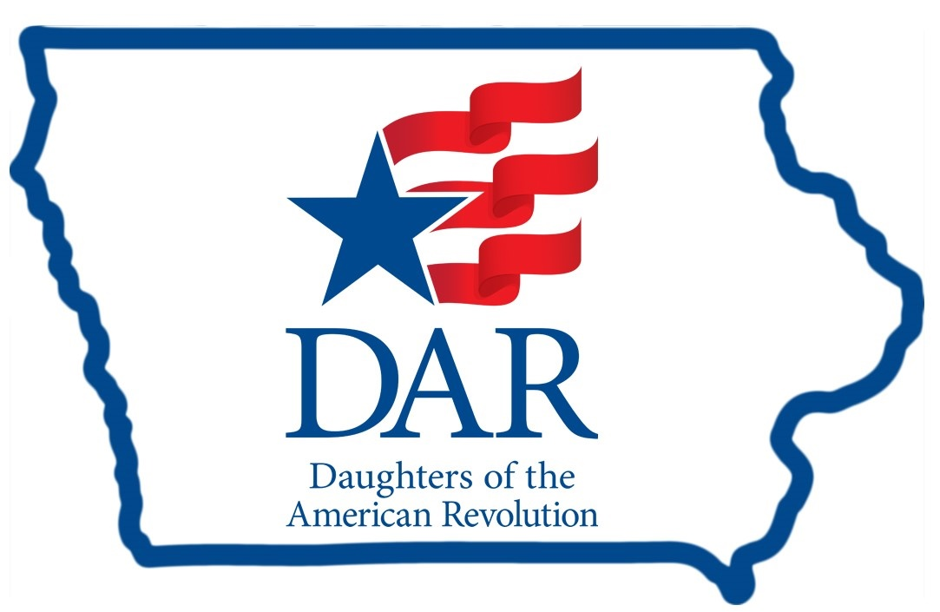

Applications are available from
[Name], DAR Scholarship Chair, [Chapter Name]
[contact information]

