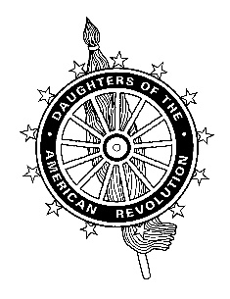

**Naturalization Ceremony Welcome**

Good morning [afternoon].

Thank you [by name or title to the host, and also recognize any dignitaries]. I deeply appreciate this opportunity to congratulate these newest citizens of the United States.

Your journey to today’s naturalization ceremony was a demanding one and you are to be congratulated for your hard work to reach this significant milestone.

As mentioned by [person who introduced you] I represent the [_______________ Chapter] of the Daughters of the American Revolution. The members of our organization are proud to trace our ancestors to some of the earliest men and women who immigrated to this country. And, most importantly, to those men and women who supported the formation of these United States through their service to the cause of the American Revolution.

Not everyone carries a rifle, not everyone fought in a battle. Some provided food or horses, others made shoes or clothing for the soldiers. Some served in local government or as clergymen or physicians aiding the efforts to win our independence.

And now, all of you, like my ancestors, the ancestors of each member of the Daughters of the American Revolution, and all generations that followed through today, join us in fulfilling the responsibilities of citizenship. We are all Americans who value our democracy and the freedoms that represents. We are all Americans who support our Constitution and the protections it provides us. It is incumbent upon all of us to honor our flag and the creed it symbolizes, *“E Pluribus Unum”, out of many we are one*.

We celebrate that you have chosen to become a United States citizen and we look forward to your energetic and enthusiastic participation in this country’s self-government. You follow in the footsteps of all the American citizens who have contributed their talents to help build this country. Your history and your past are now part of the rich fabric that is the United States.

I am delighted to be able to say to you, congratulations, my fellow Americans.

By Denise Clemons, Division Vice Chair, Americanism Committee, 2016

## National Society Daughters of the American Revolution

### Ann Turner Dillon, President General

#### AMERICANISM COMMITTEE — Cynthia Parnell, *National Chair*

0836 SW Curry St., Unit 1300, Portland, OR 97239